Hello,
My name is Jenny Dabbs and I am the leader for arts and crafts project this year. I have a few projects planned for this year so far, if there is anything you are interested in doing that is not listed below email me and I will try and put something together. I have provided dates of meetings, prices, and appropriate ages for each project. If you would like to sign up for a meeting please email me the form to let me know which projects you are interested in, return the form to me at the December general meeting, or mail back the form. All money for all projects must be turned in by the December general meeting; you can give it to me at the meeting or mail it to me. I understand that if you have several children or your child wants to sign up for several activities that writing a large check or paying cash for all at once may not be possible, talk to me and we can make arrangements. Sign up will be on a first come first serve basis. All the meetings will be held at the clover center at 1:00 pm on a Saturday, some will require indoor and outdoor activities so please dress appropriately. Any one third grade or younger must be accompanied by a parent. * When indicated anyone under 15 must be accompanied by an adult.
Email is the best way to contact me; if you have any questions feel free to ask.
My email is: jennifer.dabbs@aol.com Cell Phone: 262-902-5252
Address: 14305 Braun Rd. Sturtevant, WI 53177.
Ornaments - all ages- $10 Date to be held: Dec. 5, 2015
Sock Snowmen (2) - all ages- $10 Date to be held: Dec. 5, 2015
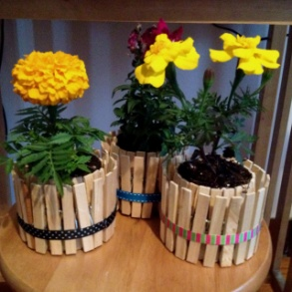
Can flower pots (2) - all ages - $10 Date to be held: April 2, 2016

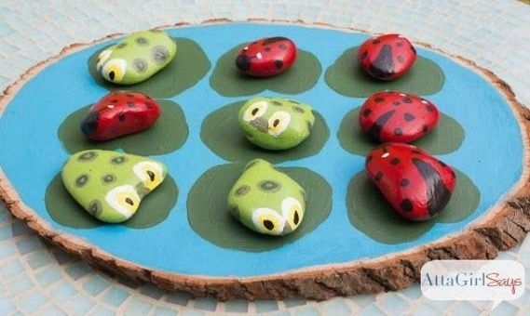
Ladybug Vs. Tadpole Tic Tac Toe – all ages - $10 Date to be held: April 2, 2016
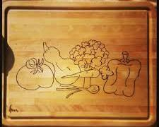 Wood burning on cutting board (your own design) – Must be at least 12* - $10 Date to be held: Jan. 2, 2016
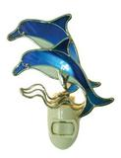
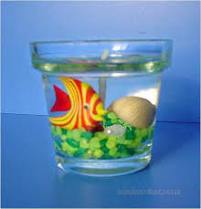 Gel Candle – all ages - $10 Date to be held: Jan. 23, 2015
Pre-cut stained glass night light (pattern of choice on back page) - Must be at least 12*- $17-24 Date to be held: Feb. 27, 2016

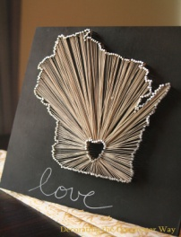
Nail art (WI & 4-H clover stencil will be available) – all ages*- $ 15 Date to be held: March 19, 2016
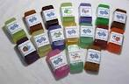
Poured soap bars: cost $10. Each person can make 3 bars. If you are allergic to glycerin; please do not sign up for this project. Date to be held: Jan. 9, 2016

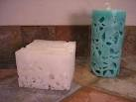 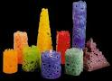 Ice Candles: cost $10. Each person can make 2 candles. Date to be held: May 28, 2016

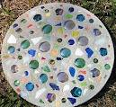 Stepping stones: Cost $10. Date to be held: June 18, 2016
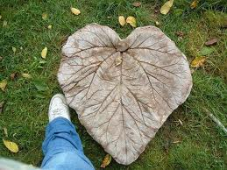 Cement Leaves: Cost $10. Date to be held: June 18, 2016

Stained Glass Night Light Options:

A.B. $17
C.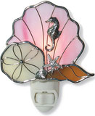D.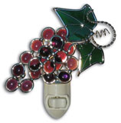$18
E.$19
F.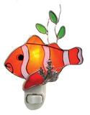 $21 G. 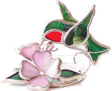$22 H. 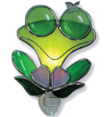$24

Arts and Craft meeting sign-up sheet
Please return to Jenny by the November General Meeting

Name: Parents Name:
Age: Parents contact Number:
Email address:
Check the activities you would like to sign-up for:
Ornaments: Cost $10 . .
Sock Snowmen: Cost $10 . .
Can flower pots: cost $10 . .
Ladybug Vs. Tadpole Tic Tac Toe: Cost $10 . .
Wood burning on cutting board: cost $10 . .
Gel Candle: Cost $10 . .
Stained glass night light: cost $17-24 . . Please indicate which pattern you would like . .
Nail art: cost $15 . .
Poured soap bars: cost $10 . .
Ice Candles: cost $10 . .
Stepping stones: Cost $10. . .
Cement Leaves: Cost $10 . .

